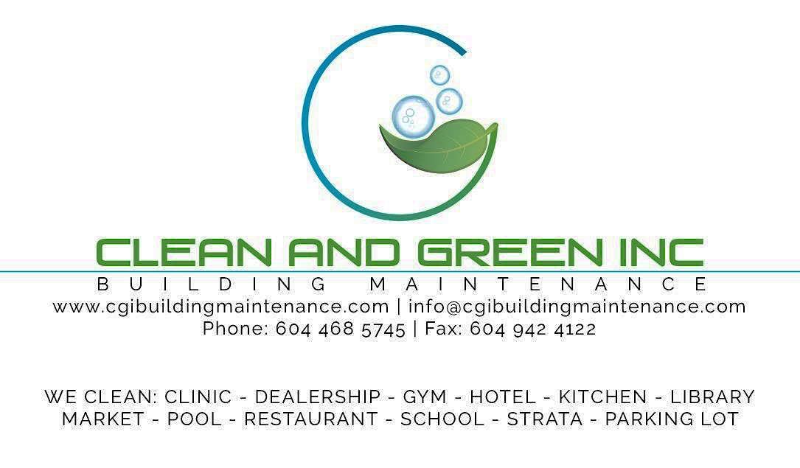

Commercial CleaningCompany Profile

Prepared by:

Ara Egos

Executive Assistant

[info@cgibuildingmaintenance.com](mailto:info@cgibuildingmaintenance.com)

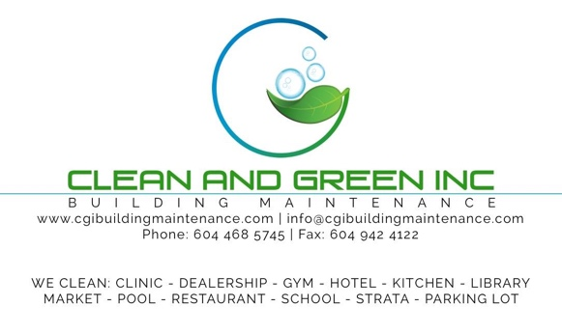

________________

**________________**

________________

________________

­­­­­­________________

________________

DearSir/Madam,

Thank you for giving Clean and Green Inc. the opportunity to submit a proposal for your janitorial services. We look forward to working with you to develop a cleaning plan that provides a clean and healthy environment for your employees and customers.

With our proposal, you will gain insight into how Clean and Green sets itself apart from other cleaning companies. One of our most important goals is to develop and maintain positive long-term relationships with our customers. We feel that our focus on these relationships, through open and clear communication, allows us to truly understand our customers and what is expected in order for us to provide the best service possible.

Our attached proposal will provide further detail about Clean & Green show and how we have the infrastructure, experience, knowledge and resources to serve you. It, will also highlight our commitment to quality through our Quality Assurance Plan, proper ang thorough training of our cleaning crews and how we maximize efficiencies by utilizing technology and other advancements like **BASECAMP** for communications.

Clean and Green Inc. has been providing services to high traffic facilities since 2007 Our crews service restaurants, strata buildings, retail business, Offices, car dealerships, libraries, hotel and schools. Our extensive experience and desire to build a mutually beneficial relationship make us the right service provider, for you.

Our company offer**FREE** extra services such as carpet wash, scrub, wax the floors and clean the grouting floors. We provide also **FREE** installation of all dispensers such as; paper towel, toilet paper dispensers. This is exclusive for first time client only.

Thank you for your time and consideration. If you have any further questions or comments, please do not hesitate to contact me.

Yours sincerely,

AmelEgos

Chief Executive Officer

Clean and Green Inc. Building Maintenance

211-3030 Lincoln Avenue | Coquitlam, BC, V3B 6B4 | Phone: 604-468.5745| Fax: 604-942-2186

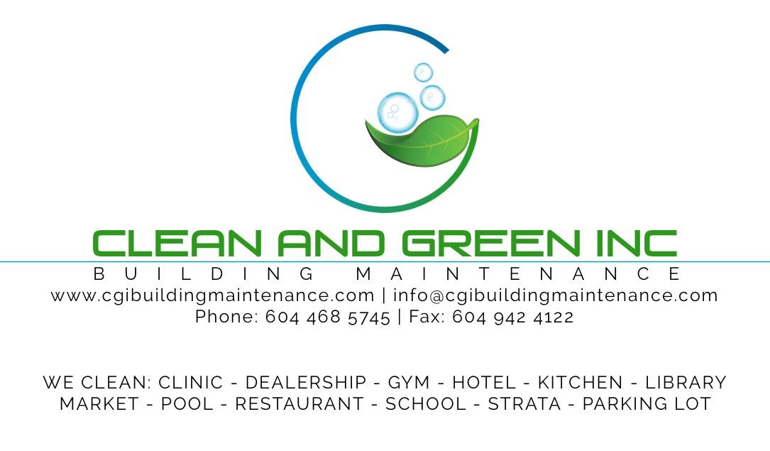

***Table of Contents***

*What makes Clean and Green UNIQUE*?........................................1

*Commercial Cleaning Experience*……………………………...….2

*Licenses*…………………………………………………………….3

*Products and Equipment Used*…………………………………...4-5

*BASECAMP*……………………………..…………………..…..6-7

*PERSONEL TRAINING AND UNIFORMS*.....................................8

*HEALTH AND SAFETY*…………………………………..……….9



***What makes Clean and Green UNIQUE?***

***CLEAN AND GREEN IS UNIQUE FOR…***

Our company, as a whole have, good attitude towards the respectable work force of the cleaning industry. We are not perfect but we work perfectly together. There is no grime that we could not expunge. Whenever there are special requests, we try our best to achieve the maximum satisfaction of the client. We keep in touch with them even after the job is done. **We are geared towards take steps to increase productivity, improve quality, and effectively manage the day-to-day operations of your business.**

***CLEAN AND GREEN IS THE BEST CHOICE BECAUSE…***

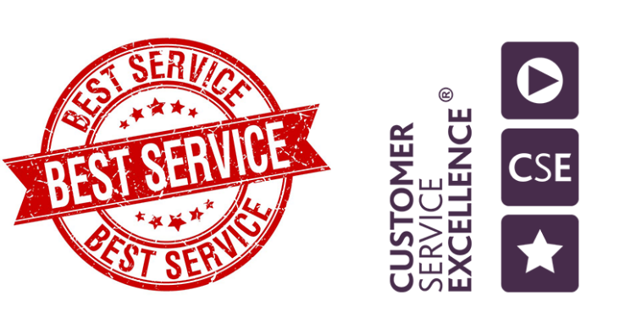Even if the business we chose is common (so a lot of competitions), the edge we have is we give our ultimate best. Although cliché, not just by words or writing, or to impress, but we try to be consistent in our job always and correct our mistakes right away. We also offer free carpet wash for new clients, depending on the contract (i.e. if clients signed a six-month contract with us then it’ll be free carpet wash for the whole duration). Most competitors have high rates for additional services but our company rates based on size of cleaning location and how much service(s) is/are needed. Here is a review from client, “They adopt a consultative approach by understanding the issues, recognizes the related constraints and offering suggestions to



***COMMERCIAL CLEANING EXPERIENCE***

address them which has proven to be fruitful and beneficial to us.

For over 10 years, Clean and Green has been successfully providing commercial cleaning services. Clean and Green is very adept at working in environments where it is important that our client looks good in their customers eyes such as casinos, movie theatres and retail locations.

We also have success in providing complete janitorial services to civic and municipal facilities, Public library, Schools, Restaurants, Strata properties, Hotel, Offices,dental clinics and Car dealers. This demonstrates our ability to offer diverse service and to developing and implementing cleaning plans to meet our clients high expectations. In addition, Clean and Green has extensive experience working in large, high traffic locations while construction and/or renovations are underway, adding the post-construction cleaning into the regular requirements and supporting the client through the process.

Clean and Green provides additional services including escalator cleaning (utilizing a Windsor Treadway escalator cleaner), post construction cleaning, carpet cleaning, hard floor maintenance, power/pressure washing and window cleaning.



***Licenses***

***Certificate of Liability Johnston Meier Insurance Agency******Group 39, Bind 5478 (Bonded)***

We have secured resources available to the customer in the event that work is completed to an unsatisfactory level and a claim is filed against the company Being bonded under a three-party insurance agreement makes sure that everyone is secured, including our clients. We want to show that we are trust worthy with our promises, contracts, and communications with our clients. We want to show that we have credibility by being bonded for our client's peace of mind because not every business is approved to get one.

***Workers Compensation Board # 967036 Business License # 750467698 Tri City of Chambers # BW0001***

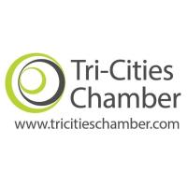We want to be proactive, our permit and license are up to date and by the book. We took out time to register, get the appropriate licensing requirements with our municipal, provincial and federal government early on in the process. We are already registered with Canada Revenue Agency.

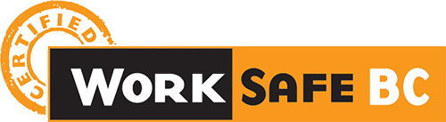***Work Safe BC***

We have an obligation to ensure the health and safety of all of our cleaners. This requires that us to comply with certain regulations and standards for the safety of the workplace. With WorkSafeBC, we comply with the legal requirements of the Occupational Health and Safety Regulation to ensure healthy and safe working conditions.



***Products and Equipment Used***

We take our definition of quality commercial cleaning, overlay our measurement of it, and then make sure we deliver it using the most advanced products and equipment available, including:

* 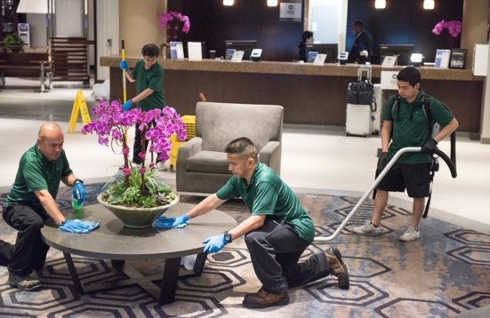Microfiber cloths designed to trap dirt and hold it in a positively charged state for more effective cleaning; these cloths are also color-coded to eliminate cross-contamination.
* Backpack vacuums with four filters ratings that exceed HEPA standards for clean air.
* Cleaning chemicals that cover a greater area while using less product – our “cleaning greener” initiative. Hospital strength disinfectants for broad spectrum coverage.

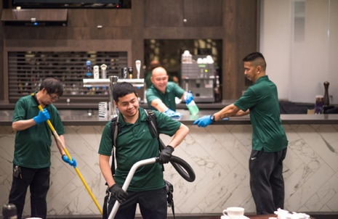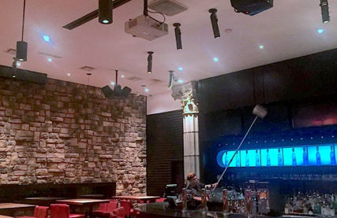



***Microfiber Cleaning Cloths***

We replaced conventional cleaning cloths with an anti-microbial impregnated micro-fiber system, which cleans greener and dryer while removing more dust contaminants. Our microfiber mops also work efficiently to clean and disinfect floor surfaces with fewer chemicals and faster results.The tiny fibers penetrate the microscopic pores of surfaces increasing cleaning quality and saving time in the process.

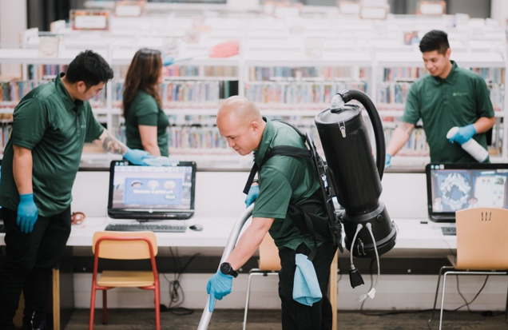***Back-Pack Vacuum***

Our teams are trained to exclusively use our approved backpack vacuums, which use a four-part HEPA filter system. This removes up to 99.9% of particles up to the size of 0.3 microns from the inside air. These powerful vacuumsthat capture up to 99% of dust mites, pollen, viruses, bacteria and chemical residue o Leave less dust and create a healthier environment for your property and its occupants

***Environmentally Safe Chemicals***

We’re proud to work within the spirit and the framework set forth by many federal agencies, including the Environmental Protection Agency, Department of Agriculture, and OSHA to name a few. We work with Spartan Chemical company to provide Green Seal® certified products and disinfectants that are effective against methicillin resistant



**Basecamp**

Basecamp is an online project management program that we use for most of our communications regarding the management of cleaning services at a client’s location. It is a central place to post messages, discussions, files, photos and specifications. There is a calendar component where we can schedule cleaning duties that occur weekly, monthly, semi annually or an irregular schedule,

Access to Basecamp is 24/7, 365 days a year via computer or smartphone. People included in the workspace are typically Clean and Green Managers, (General Manager, Operations Manager, Office/Payroll Manager, Controller, specific supervisors and designated client representatives.)

The many benefits that our clients would receive by utilizing Basecamp are:

* To be in the loop about Clean and Green operations at their location
* To be able to contribute information, comments, feedback and questions
* To have a place where Clean and Green activity is documented
* To have access to information 24/7
* To see Before and After pictures, where applicable
* To have access to the calendar that shows the schedule of upcoming work
* To post pictures of areas that need cleaning or maintenance attention
* To have an efficient method of documenting any issues
* To be able to post any last-minute cleaning special requests
* To update all people in the client’s Basecamp workspace with one post

A further benefit to using this platform is that it allows us to limit paper usage which is in keeping with our “Green” initiatives.

Basecamp is an incredibly easy and effective way of communicating. It is the disrupter of the old school way of managing cleaning services, both from the clients and cleaning company’s perspective.

Note:Private, sensitive of confidential communication or information are not posted on Basecamp.

To see the general Basecamp website, go to www.basecamp.com.



**Personnel and Training**

***PERSONNEL***

At Clean and Green, we recognize that our staff are responsible for creating the best possible impression of a client’s business to its customers. We are selective in our hiring process and our CITS designed training procedures sets our cleaners up for success.

***CLEANING INDUSTRY TRAINING STANDARDS CITS***

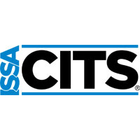Our training program was designed using the Cleaning Industry Training Standard (CITS).This standard was developed by the International Sanitary Supplies Association, The cleaning industry association, along with input from experts in all areas of the cleaning industry.

The Cleaning Industry Training Standards are designed to facilitate the development, adoption and performance of effective training programs. The standards provide a framework that can be used to ensure that training programs contain best practice elements and are designed to put cleaning service workers in the best position to succeed.

By utilizing the CTIS framework, Clean and Green designed a very effective employee training program which aims to set our employees up for success which ultimately benefits our client’s Notable elements of our training program include.

* Cleaning techniques for specific areas like restroom cleaning, mirrors and glass, various surface types
* Maximizing workflow efficiency
* Proper use of equipment
* Hard floor maintenance and carpet maintenance
* Adhering to laws, rules, regulations and codes relative to their work
* Knowledge checks and quizzes
* Health and safety in the Workplace, WHIMIS, MSDS sheets, WCB WorkSafe
* Policies on areas such as Pathogen PIM Spills Cleanup Policy and Needles and Sharps Cleanup Policy (these policies can be viewed in the attachments)
* Customer service training
* Green cleaning training
* Emergency procedures
* Checklist including an Employee Training Checklists

Our clients benefit from our training program by having properly and thoroughly trained cleaners looking after and maintaining their facilities.

***UNIFORMS***

Clean and Green staff where uniforms consisting of a polo shirt in green or black, and with Clean and Green logo embroidered on upper left side of the chest. The bottoms are black or dark coloured pants and shoes.

***HEALTH AND SAFETY***

Clean and Green always operates within all laws, rules, regulations, codes and established operating procedures in order to provide safe and reliable services with regards to public and occupant safety, comfort and convenience.

The health and safety of our employees is a top priority. Not only do we comply with all laws and regulations surrounding safety in the workplace, we have our own Health and Safety Manual which documents policies and procedures.

The Clean and Green Health and Safety Manual outlines our responsibilities and commitment to all Clean and Green employees. An excerpt from our Health and Safety Manual purpose statement is:

*As a quality driven service company, it is our responsibility and commitment that all Clean and Green Employees will perform their jobs in compliance with our Health and Safety policies and standards and within all applicable laws and regulations.*